Data Structure and Algorithm
Laboratory Activity No. 13

Tree Algorithm

Submitted by: | Instructor:
Monoy, Justin Rhey A. | Engr. Maria Rizette H. Sayo

November, 08, 2025

Objectives
Introduction
An abstract non-linear data type with a hierarchy-based structure is a tree. It is made up of links connecting nodes (where the data is kept). The root node of a tree data structure is where all other nodes and subtrees are connected to the root.

This laboratory activity aims to implement the principles and techniques in:
- To introduce Tree as Non-linear data structure
- To implement pre-order, in-order, and post-order of a binary tree
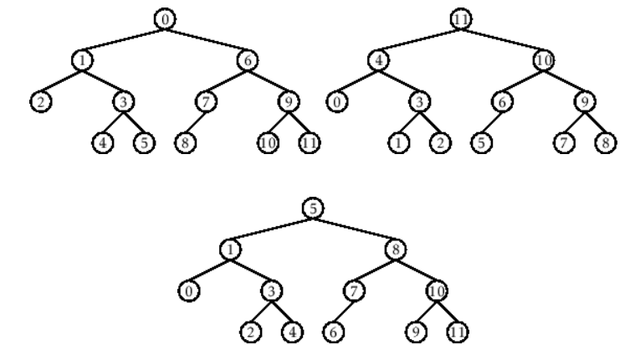

- Figure 1. Pre-order, In-order, and Post-order numberings of a binary tree

Methods
  - Copy and run the Python source codes.
  - If there is an algorithm error/s, debug the source codes.
  - Save these source codes to your GitHub.
  - Show the output

    - Tree Implementation

class TreeNode:
def __init__(self, value):
self.value = value
self.children = []

def add_child(self, child_node):
self.children.append(child_node)

def remove_child(self, child_node):
self.children = [child for child in self.children if child != child_node]

def traverse(self):
nodes = [self]
while nodes:
current_node = nodes.pop()
print(current_node.value)
nodes.extend(current_node.children)

def __str__(self, level=0):
ret = " " * level + str(self.value) + "\n"
for child in self.children:
ret += child.__str__(level + 1)
return ret

# Create a tree
root = TreeNode("Root")
child1 = TreeNode("Child 1")
child2 = TreeNode("Child 2")
grandchild1 = TreeNode("Grandchild 1")
grandchild2 = TreeNode("Grandchild 2")

root.add_child(child1)
root.add_child(child2)
child1.add_child(grandchild1)
child2.add_child(grandchild2)

print("Tree structure:")
print(root)

print("\nTraversal:")
root.traverse()

Questions:
- When would you prefer DFS over BFS and vice versa?
- What is the space complexity difference between DFS and BFS?
- How does the traversal order differ between DFS and BFS?
- When does DFS recursive fail compared to DFS iterative?

Results
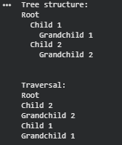
Figure 1: Tree Structure

1. When I need to identify a path between two nodes in a tree, when memory use is important, or when I need to determine whether the graph is connected or has cycles, I would prefer DFS over BFS. When I need to find the shortest path in a graph or tree, when I need to perform level order traversal, when I want to locate every node at a specific distance, or when the graph is wide but not very deep, I would choose BFS rather than DFS.
2. The space difference between DFS and BFS in a tree is that BFS is used to determine the tree's maximum width, whereas DFS is used to determine the tree's maximum height or depth.
3. In DFS, it enters a branch for as long as possible before returning. Before attempting a different task, it completes one. Before going deeper, BFS checks each node on the same level. The tree or graph is traversed level by level.
4. Recursive DFS might not work well in very deep trees, especially when each node has only one child. This is because it uses the system’s call stack, which has a limit and can cause a stack overflow error. Iterative DFS is safer for deep or uneven trees because it uses its own stack in memory. That’s why iterative DFS is more reliable for big trees, even though recursive DFS is easier to write.

Conclusion
In order to be clear, each has specific uses and both DFS and BFS are important methods for examining graphs and trees. The best method for determining the shortest path in graphs without weights is BFS, which checks level by level. In deep yet narrow structures, DFS utilizes less memory and travels as deep as it can before turning around. While recursive DFS is simpler to implement but may fail in very deep trees due to stack overflow, iterative DFS is safer for large or uneven trees because it utilizes its own stack. In general, deciding between DFS and BFS depends on the graph's depth or width, memory usage, and traversal order.

References
[1] GeeksforGeeks, “Difference between BFS and DFS,” GeeksforGeeks, Nov. 01, 2025. https://www.geeksforgeeks.org/dsa/difference-between-bfs-and-dfs/
[2] Wikipedia contributors, “Depth-first search,” Wikipedia, Oct. 23, 2025. https://en.wikipedia.org/wiki/Depth-first_search
[3] AlgoDaily, “AlgoDaily - Daily coding interview questions. Full programming interview prep course and software career coaching.” https://www.algodaily.com/lessons/dfs-vs-bfs

